INFOSYS SPRINGBOARD
NARRATIVE FLOW
Story Co-Writer
INKFORGE
Phase 2 — Ollama LLM Integration Documentation
Submitted by: Subasri B
Infosys Springboard Project

Local LLM · Ollama REST API · Prompt Engineering · Streaming Inference

1. Introduction to Ollama
Ollama is an open-source framework that allows large language models (LLMs) to be run entirely on local hardware, without sending any data to external servers. It provides a lightweight runtime that manages model downloading, hardware acceleration, and an HTTP REST API for inference — making it straightforward to integrate any LLM into an application.

In the context of INKFORGE, Ollama serves as the AI backbone for all story generation, workshop tools, title extraction, and character detection. Every call to the AI is a direct HTTP POST to the locally running Ollama server — no cloud dependency, no API keys, and no usage costs.

Why Ollama for INKFORGE?
Consideration | Ollama Advantage
Privacy | All story content stays on the user's machine — nothing is transmitted externally
Cost | Zero inference cost after initial model download — no tokens, no subscriptions
Latency | Local inference eliminates network round-trip latency for faster streaming
Model Flexibility | Any Ollama-compatible model can be swapped in via the MODEL selector in the UI
Offline Use | Fully functional without an internet connection once models are downloaded
Control | Full access to inference parameters — temperature, top_p, repeat_penalty, num_predict

Ollama Architecture Overview
Ollama runs as a background service on the host machine, listening on port 11434 by default. It exposes a REST API with endpoints for model management and chat inference. INKFORGE communicates with Ollama exclusively via the /api/chat endpoint, using the messages array format compatible with OpenAI-style chat models.

Ollama Service: http://localhost:11434
Inference Endpoint: POST /api/chat
Model Management: GET /api/tags
Default Model: llama3 (configurable via UI)
Streaming: Supported via newline-delimited JSON (NDJSON)

2. Ollama Setup & Configuration
Ollama is installed as a native application on the host operating system. Once running, it manages model storage, GPU/CPU resource allocation, and serves the REST API automatically in the background. No configuration files are required for basic usage.

Installation
# macOS / Linux
curl -fsSL https://ollama.com/install.sh | sh

# Windows
# Download installer from: https://ollama.com/download

# Start the Ollama service
ollama serve

# Pull the default model used by INKFORGE
ollama pull llama3

Verifying the Connection
INKFORGE includes a TEST button in the Forge tab configuration strip. This button makes a GET request to /api/tags and displays the number of locally available models, confirming that the Ollama service is reachable before any story generation is attempted.

# INKFORGE connection test (Python)
import requests

OLLAMA_URL = 'http://localhost:11434'

def get_models():
try:
r = requests.get(f'{OLLAMA_URL}/api/tags', timeout=3)
if r.status_code == 200:
return [m['name'] for m in r.json().get('models', [])]
except:
pass
return []

Supported Models
Any model available through the Ollama library is compatible with INKFORGE. The model selector in the Forge tab dynamically lists all models returned by /api/tags, allowing the user to switch models at any time during a session.

Model | Parameters | Recommended Use
llama3 | 8B | Default — strong writing quality, fast on consumer hardware
llama3:70b | 70B | Highest quality prose — requires 48GB+ VRAM
mistral | 7B | Fast and capable — good alternative to llama3
gemma2 | 9B / 27B | Strong creative writing, efficient on Apple Silicon
phi3 | 3.8B / 14B | Lightweight option for lower-spec machines

3. Ollama API Integration

INKFORGE integrates with Ollama through direct HTTP requests using Python's requests library. All inference calls target the /api/chat endpoint with a JSON payload containing the model name, message array, streaming flag, and inference parameters.

Request Structure
Every story generation call sends two messages to Ollama: a system message containing all story settings (genre, tone, POV, mood, characters, world context), and a user message containing the story so far plus the author's direction for what to generate next.

payload = {
'model': st.session_state.ollama_model,
'messages': [
{'role': 'system', 'content': system_prompt},
{'role': 'user', 'content': user_message}
],
'stream': True,
'options': {
'temperature': 0.82,
'top_p': 0.90,
'repeat_penalty': 1.06,
'num_predict': 500
}
}

response = requests.post(
f'{OLLAMA_URL}/api/chat',
json=payload,
stream=True,
timeout=180
)

Inference Parameters
Parameter | Value & Purpose
temperature | 0.82 — Controls randomness. Higher values produce more creative, varied prose; lower values are more predictable.
top_p | 0.90 — Nucleus sampling. Only tokens within the top 90% probability mass are considered, balancing diversity and coherence.
repeat_penalty | 1.06 — Penalises the model for repeating recently used tokens, reducing repetitive phrasing in long passages.
num_predict | 500 — Maximum tokens to generate per call, roughly 350–400 words of prose per passage.
timeout | 180s — Request timeout allowing for slower hardware or larger models to complete generation.

4. Streaming Response Handling

INKFORGE uses Ollama's streaming mode for all story generation. Rather than waiting for the complete response before displaying it, the application reads the response as a stream of newline-delimited JSON objects (NDJSON), each containing a single generated token. This creates a live typing effect in the UI as the story is written.

Streaming Implementation
full_text = ''
placeholder = st.empty() # Streamlit live-update placeholder
chunk_counter = 0

for line in response.iter_lines():
if not line:
continue
try:
chunk = json.loads(line.decode())
token = chunk.get('message', {}).get('content', '')
if token:
full_text += token
chunk_counter += 1
# Update UI every 8 tokens to balance responsiveness
if chunk_counter % 8 == 0:
placeholder.markdown(
f'<div class="nf-streaming">{full_text}▌</div>',
unsafe_allow_html=True
)
if chunk.get('done'):
break
except:
continue

placeholder.empty() # Clear streaming preview

NDJSON Response Format
Each line in the streaming response is a self-contained JSON object. Ollama sends one object per token during generation, and a final object with done: true when the generation is complete.

# Mid-stream token object:
{'model': 'llama3', 'message': {'role': 'assistant', 'content': 'The'}, 'done': false}

# Final done object:
{'model': 'llama3', 'message': {'role': 'assistant', 'content': ''}, 'done': true,
'total_duration': 4821000000, 'eval_count': 312, 'eval_duration': 4100000000}

UI Update Strategy
The placeholder is updated every 8 tokens rather than every token. This reduces Streamlit rerender frequency, which would otherwise cause visible flicker and slow down the streaming experience. A blinking cursor character (▌) is appended to the in-progress text to indicate active generation.

5. Prompt Engineering

The quality and consistency of INKFORGE's output is determined entirely by the prompts sent to Ollama. The system uses a two-layer prompt architecture: a detailed system prompt that establishes the AI's persona and all story settings, and a user message that provides story context and the specific generation directive.

System Prompt Structure
The system prompt is dynamically assembled from the user's current session settings. It is rebuilt on every generation call to reflect any changes to genre, tone, POV, mood, characters, or world context.

You are a master fiction writer — skilled, literary, and precise.
Your prose is of publishable quality. You write like a seasoned novelist.
You write ONLY story prose. Never explain, never break character.

STORY SETTINGS:
GENRE: {genre} (e.g. Fantasy, Thriller, Romance)
GENRE STYLE: {genre_style_hint}
TONE: {tone} (e.g. Cinematic, Lyrical, Dark & Gritty)
TONE INSTRUCTION: {tone_hint}
POINT OF VIEW: {pov} (e.g. First Person, Third Person)
SCENE MOOD: {mood} (e.g. Tense, Melancholic, Hopeful)

ESTABLISHED CHARACTERS:
{character_list}

WORLD / CONTEXT:
{world_context}

CURRENT ACTION: {action_instruction}
TARGET LENGTH: {word_target}

Action-Specific Instructions
Each of the ten action types (Continue, Enhance, Rewrite, Plot Twist, Dialogue, Describe, Foreshadow, Raise Stakes, Flashback, End Chapter) injects a specialised directive into the system prompt that reshapes how the model approaches the generation task.

Action | Directive Summary
Continue | Continue the story naturally from where it left off, maintaining voice and momentum
Enhance | Elevate prose quality of the last passage — do not advance the story forward
Rewrite | Completely reimagine the last passage with fresh structure and imagery
Plot Twist | Introduce a surprising twist that feels inevitable in hindsight
Dialogue | Add a subtext-rich dialogue scene where characters reveal through what they do not say
Describe | Write a rich five-sense descriptive passage for the current scene
Foreshadow | Continue while planting subtle hints of future events without revealing outcomes
Raise Stakes | Escalate urgency, danger, or emotional cost; continue with heightened tension
Flashback | Insert a meaningful past memory triggered by a sensory detail, then return to present
End Chapter | Write a satisfying beat plus a hook that drives the reader compulsively forward

6. Multi-Task Inference
Beyond story generation, INKFORGE uses Ollama for three additional inference tasks, each with its own optimised prompt and parameter set: automatic title suggestion, automatic character and world extraction, and workshop/coaching queries.

Title Extraction
After the first story passage is generated, INKFORGE makes a separate non-streaming Ollama call to extract a compelling 2-5 word title from the opening text. The call uses a low temperature to ensure a focused, deterministic response.

prompt = f'''Read this story opening and suggest ONE short, compelling title.
The title should be evocative, literary, and 2-5 words long.
Reply with ONLY the title — no quotes, no explanation.

STORY OPENING:
{text[:600]}'''

response = requests.post(f'{OLLAMA_URL}/api/chat', json={
'model': model,
'messages': [{'role': 'user', 'content': prompt}],
'stream': False,
'options': {'temperature': 0.7, 'num_predict': 20}
})

Automatic Character & World Extraction
After every story generation, INKFORGE optionally calls Ollama to extract named characters and infer world/setting details from the new passage. This only runs when the user has not manually filled those fields, and uses a very low temperature (0.1) for accurate, consistent extraction.

# Extraction prompt (condensed)
prompt = f'''Read this story passage and extract:

CHARACTERS: List every named character. Format:
Name - their role in one short phrase. One per line.

WORLD: In 1-3 bullet points, infer setting, time period,
and any unique rules of this world. Write NONE if plain.

PASSAGE: {story_text[:1200]}
Reply ONLY with extracted information. No commentary.'''

# Parameters: low temperature for factual extraction
'options': {'temperature': 0.1, 'num_predict': 200}

Workshop Inference
The six Workshop tools and Story Compass use a modified system prompt that frames Ollama as an expert creative writing coach rather than a fiction writer. These calls use temperature 0.7 and num_predict 600 to allow longer, more analytical responses appropriate for craft guidance.
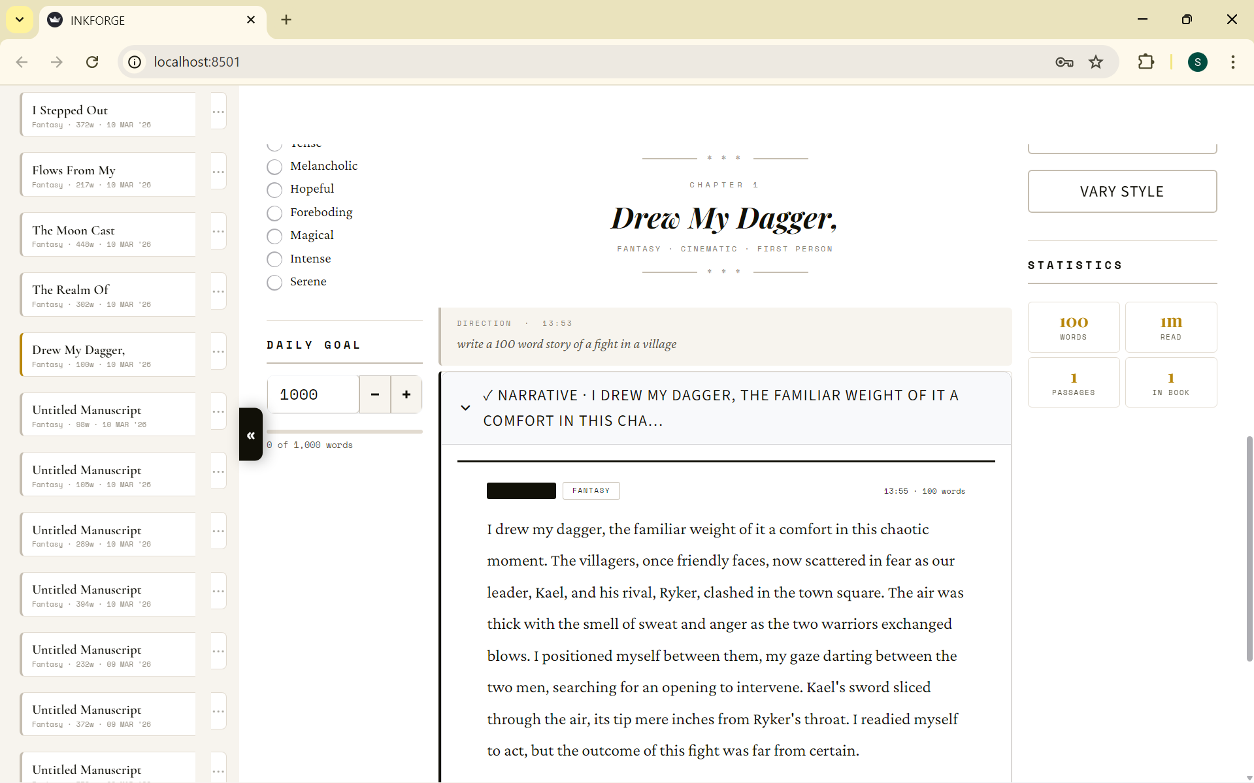

7. Genre, Tone & Mood Configuration

One of the most significant factors in output quality is the specificity of the style guidance embedded in the system prompt. INKFORGE maintains a structured configuration for all eight genres, six tones, four POVs, and eight scene moods — each contributing targeted instructions that shape the model's writing style.

Genre Configuration
Each genre carries a style_hints string that is injected directly into the system prompt. This tells the model not just what genre to write in, but how to approach the prose technically.

Genre | Style Hint (injected into system prompt)
Fantasy | Use archaic but accessible language. Evoke wonder and grandeur. Include sensory details of magical elements.
Sci-Fi | Blend hard science with human emotion. Use precise technical language mixed with philosophical depth.
Thriller | Short punchy sentences for tension. Build dread. Use unreliable perception. Every detail should feel threatening.
Romance | Focus on internal emotional states. Use rich sensory details. Let tension simmer before resolution.
Horror | Build atmosphere slowly. Use silence and absence as tools. Let dread accumulate. Avoid cheap scares.
Mystery | Plant clues subtly. Every detail matters. Maintain red herrings. Voice should feel sharp and observational.
Historical | Research accuracy matters. Use period-appropriate language without alienating readers.
Literary | Prioritise interiority and psychological depth. Use metaphor and motif deliberately. Every sentence must carry weight.

Tone & Mood Layering
Tone and mood are separate layers of instruction. Tone describes the overall narrative register (Cinematic, Lyrical, Dark & Gritty, Whimsical, Epic, Intimate). Mood describes the emotional atmosphere of the current scene and can shift from passage to passage without changing the overall tone of the story.

Example — Combined Tone + Mood instruction:

TONE: Cinematic
TONE INSTRUCTION: Write with visual clarity and pacing. Scene transitions should feel like cuts.
Action should be choreographed with precision.

MOOD: Foreboding
MOOD INSTRUCTION: Something is wrong but nobody can name it yet.
Let dread accumulate in the details.

8. Error Handling & Performance

Connection Error Handling
All Ollama requests are wrapped in try/except blocks. If the Ollama service is not running or unreachable, INKFORGE displays a clear error message directing the user to start the service with ollama serve — the application does not crash or enter an undefined state.

try:
response = requests.post(
f'{OLLAMA_URL}/api/chat',
json=payload, stream=True, timeout=180
)
response.raise_for_status()
# ... process stream ...

except requests.exceptions.ConnectionError:
st.error('Ollama not running — start with: ollama serve')

except Exception as e:
st.error(f'Generation error: {e}')

Extraction Fault Tolerance
The character and world extraction calls are explicitly marked as best-effort. They are wrapped in a broad except Exception: pass block so that any failure in the secondary extraction call never interrupts or delays the story generation flow. The story block is always saved to session state regardless of extraction outcome.

Performance Considerations
Factor | Approach in INKFORGE
Stream update frequency | Placeholder refreshed every 8 tokens — balances live feedback with Streamlit rerender cost
Context window | Only the last ~800 characters of existing story are sent as context, keeping payloads small
Extraction calls | Run after story generation completes — non-blocking from the user's perspective
Title extraction | num_predict capped at 20 tokens — completes in under 1 second on typical hardware
Workshop calls | Use stream=True with same 8-token update cadence for consistent UX across all features
Connection timeout | 180 seconds — generous for slow hardware; TEST button lets users verify before writing

Model Selection Impact
The choice of Ollama model directly affects generation speed and prose quality. Smaller models (3B–8B parameters) generate 20–50 tokens per second on consumer CPUs, while GPU-accelerated 70B models can match or exceed cloud API speeds. INKFORGE's UI is model-agnostic — any model can be selected at any time, and the prompt structure adapts automatically.

9. Phase 2 Summary

Integration Delivered
- Full Ollama REST API integration using Python requests library with streaming support
- Dynamic system prompt construction incorporating genre, tone, POV, mood, characters, and world context
- Ten action-specific prompt directives shaping distinct generation modes
- Real-time streaming output rendered in Streamlit with live token-by-token display
- Non-streaming inference for title extraction (num_predict: 20, temperature: 0.7)
- Non-streaming character and world extraction (num_predict: 200, temperature: 0.1)
- Workshop and coaching inference with separate system persona (temperature: 0.7, num_predict: 600)
- Dynamic model discovery via /api/tags — supports any Ollama-compatible model
- Graceful error handling for connection failures, stream errors, and JSON parse exceptions
- Automatic session saving after every successful generation

Technical Architecture Summary
Component | Technology | Role
LLM Runtime | Ollama (local) | Model management, hardware acceleration, REST API server
Inference Client | Python requests | HTTP POST to /api/chat with streaming response reading
Prompt Builder | StoryEngine class | Assembles system + user message from session state on every call
Stream Handler | iter_lines() loop | Reads NDJSON tokens, accumulates text, updates Streamlit placeholder
State Management | st.session_state | Persists story blocks, word count, characters, world context across rerenders
Auto-Save | save_session_to_history() | Writes updated session to user's JSON history file after each generation

Phase 3 — Planned Scope
- Content guardrail layer — LLM-based pre-screening to restrict Ollama to story-only topics
- Streaming formatting persistence — bold/italic/underline applied in the viewer saved back to story blocks
- Cloud LLM fallback — optional OpenAI / Anthropic API support when Ollama is unavailable
- Fine-tuning pipeline — domain-specific model fine-tuning on literary fiction corpora
- Multi-turn conversation memory — passing full story history as context for longer coherence

Phase 2 Status: COMPLETE
Submitted by: Subasri B
Project: Narrative Flow Story Co-Writer — INKFORGE
Programme: Infosys Springboard
Integration: Ollama Local LLM via REST API · Python requests · Streamlit

